Please go to <http://www.utdallas.edu/~hxp151330/ajaxCall.html> to check

**Before click**

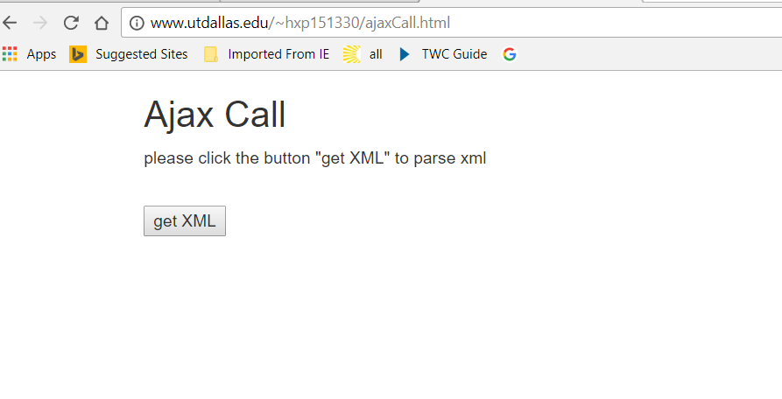

**After Click**

